This document reviews the new changes/request for the admin dashboard.

# Dashboard – admin/dashboard.html

The admin dashboard has a jQuery widget that allows the user to move the widgets around and customize their own dashboard. Once a widget has been moved, the save button that is commented out on the dashboard should display.

1. **Errors**

**Help Requests –** Displays the list of help request submissions that is received from the /admin/help-request.html page. The submissions on the help form on /admin/help-request.html should be sent to [lmsitsupport@ioausa.com](mailto:lmsitsupport@ioausa.com).

**Pending Claims** – When clicked, it should take the user to a page with pending claims filtered - admin/pending-claims.html shows an example.

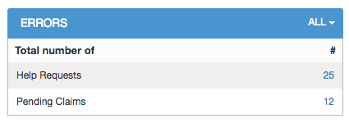

1. **Expiring Policies**

Same functionality as before, just displayed differently.

**NOTE**: The dropdown drops down to **either** the risk advocate or the date filter.

1. 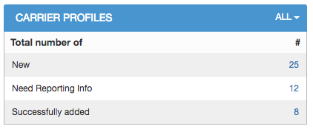**Carrier Profiles**

**New** - Displays a list of the last 24 hours of new carrier/policies added.

**Need Reporting Info -** Displays a list with carriers that are missing information. Click the number 12 to see an example.

**Successfully added –** Displays a list with carriers that have been successfully added. Click the number 8 to see an example.

1. **Clients/Servicing Team/Activity**

Same functionality as producers’ dashboard.

1. **Daily Log**

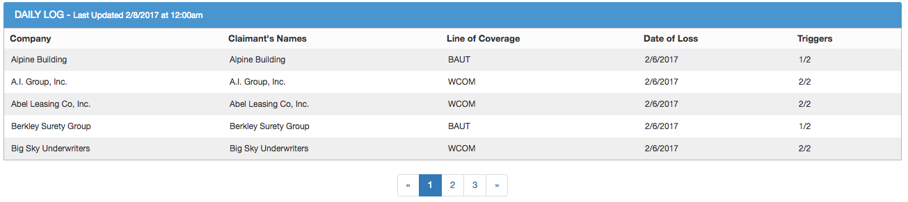

List of new claims updated in the last 24 hours.

1. 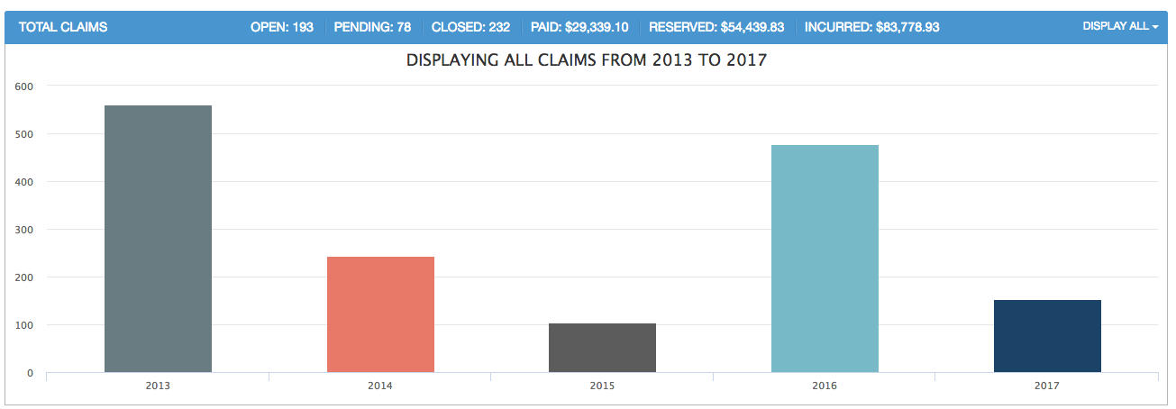**Total Claims**

Same graph that is used for the producers’ highcharts dashboard will be used here.